What we created?

We've created an interactive Exoplanet model designed for everyone. This innovative tool goes beyond mere entertainment; it enables users to explore and understand the potential existence of life in distant corners of the universe. By showcasing how life might appear and endure in such environments, the model educates individuals about the complexities of living on exoplanets. This knowledge prepares us for the future prospect of human colonization.

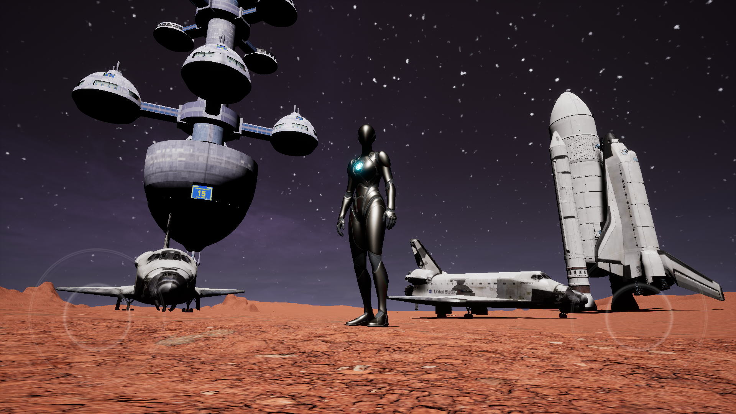

In our model, users can experience a lot of things that should be situated in an exoplanet. We have added some models from NASA resources like space shuttle, Spacecraft, Rovers, and other models, which make our Exoplanet habitable.

We created a museum where we exhibit space-related objects such as some exoplanets 3D models, space satellites, the James Webb telescope, Voyager 2, ISS (International Space Station), Lunar module provided by NASA. Users can visit the museum and see detailed information about these Exhibit models.

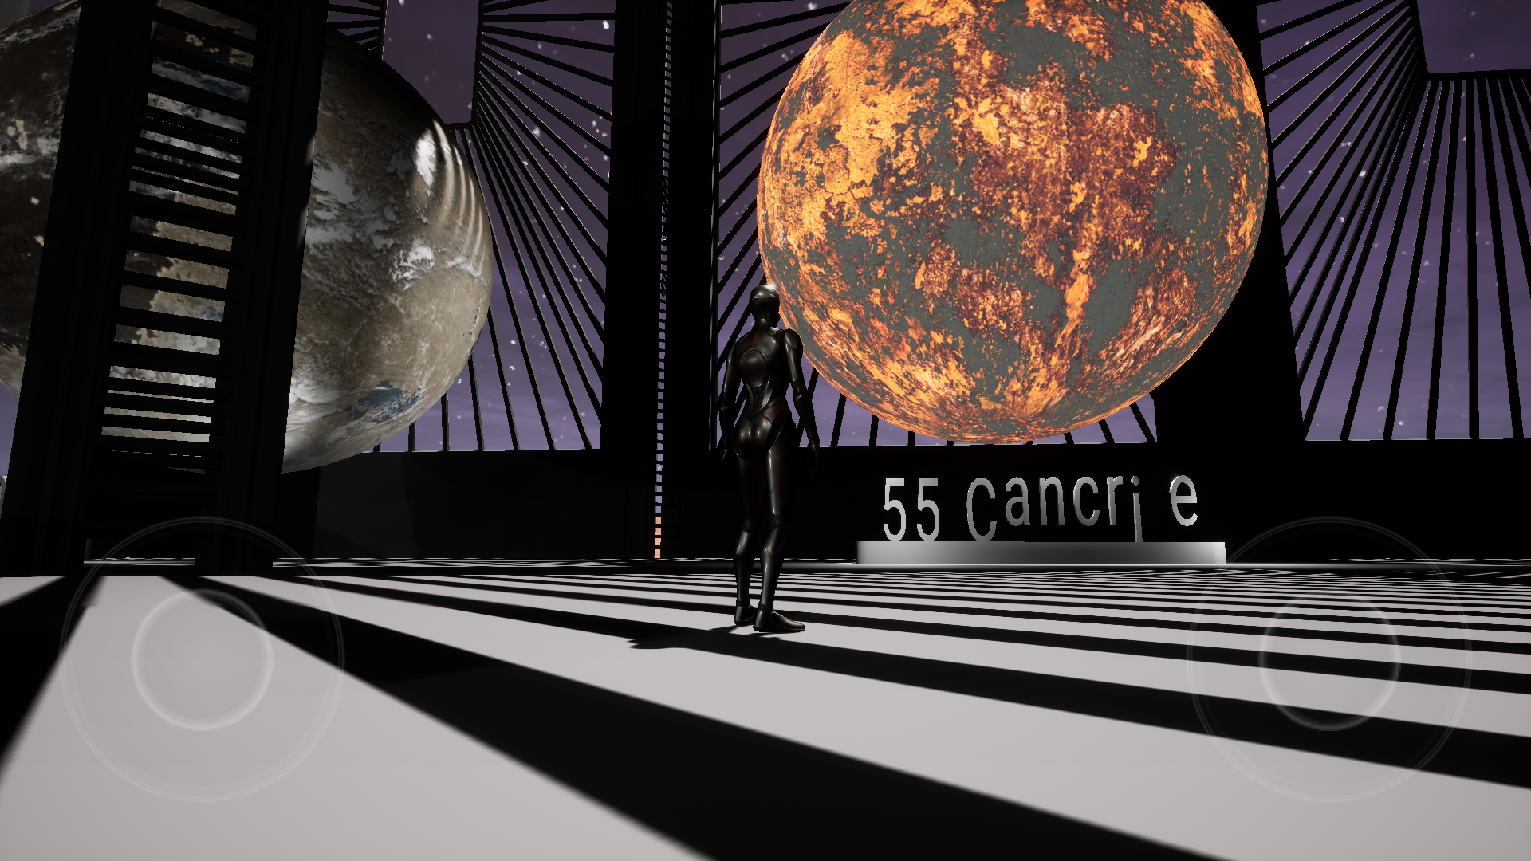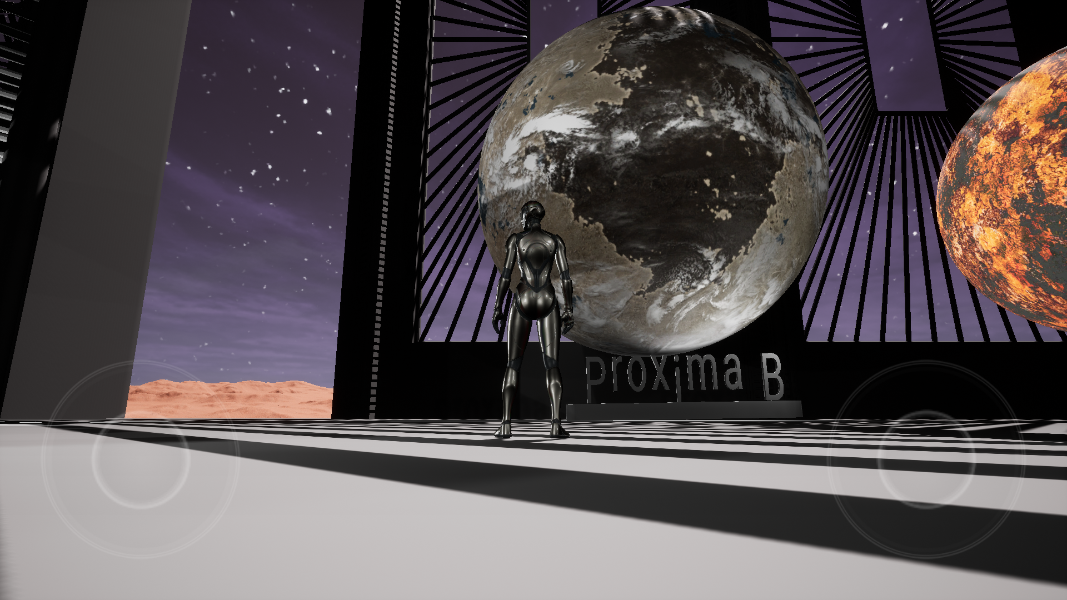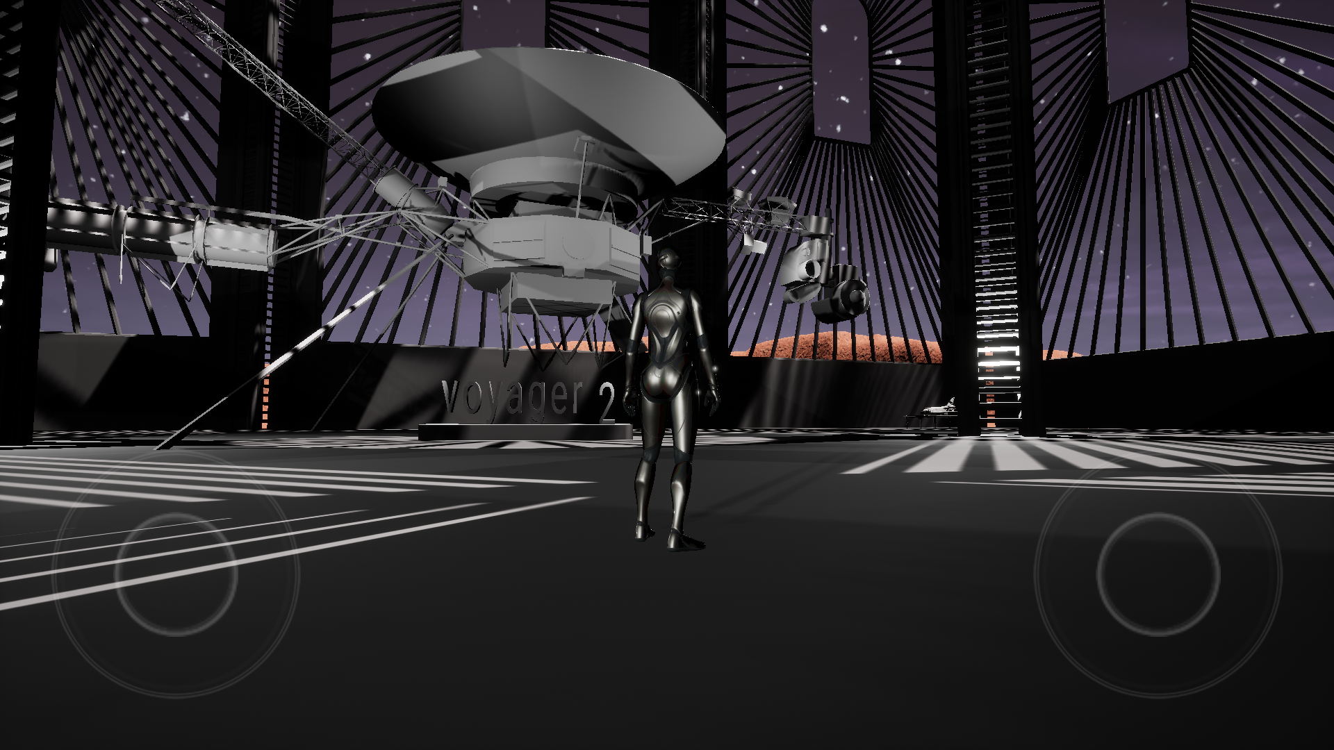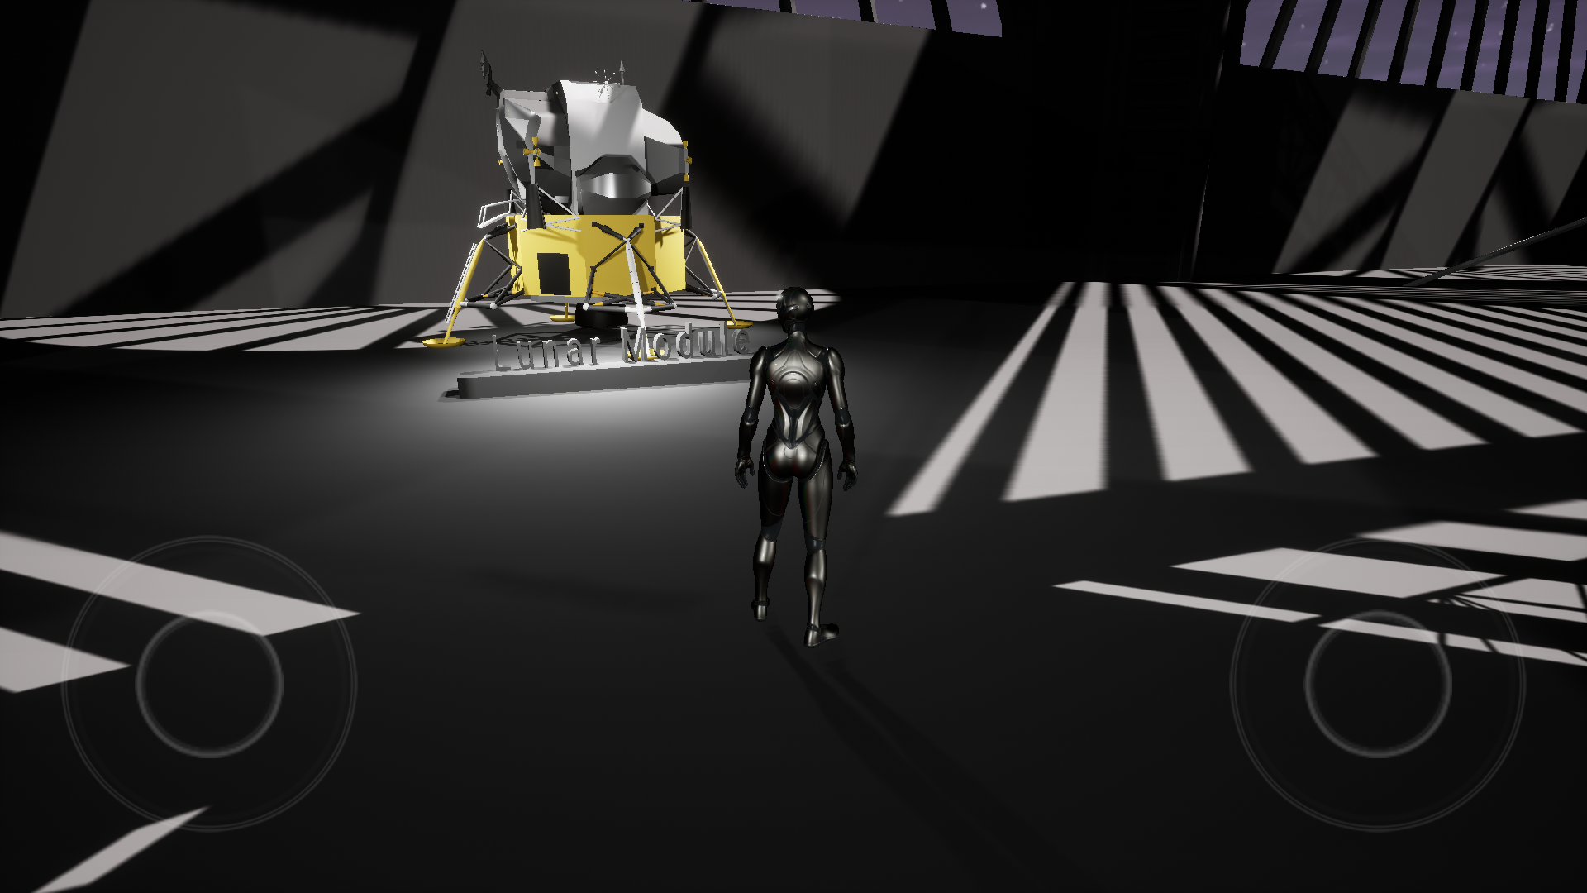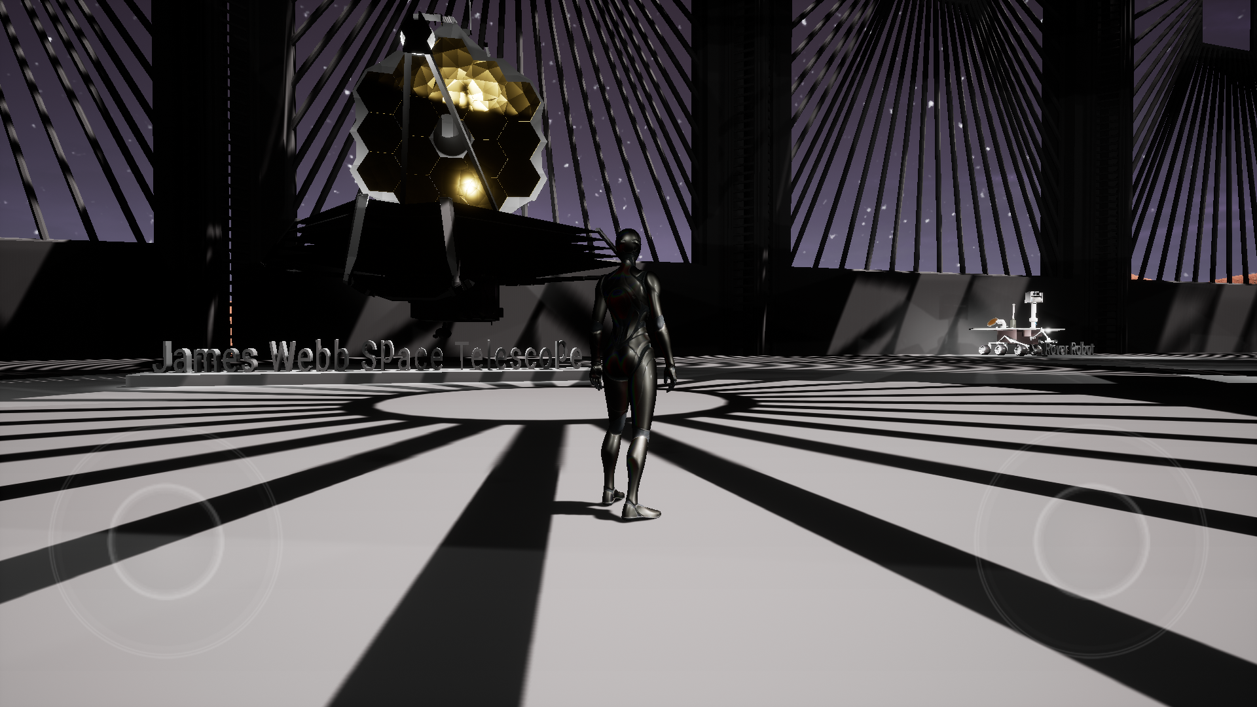

Water resources and Cultivation land are here which make our Exoplanet habitat.

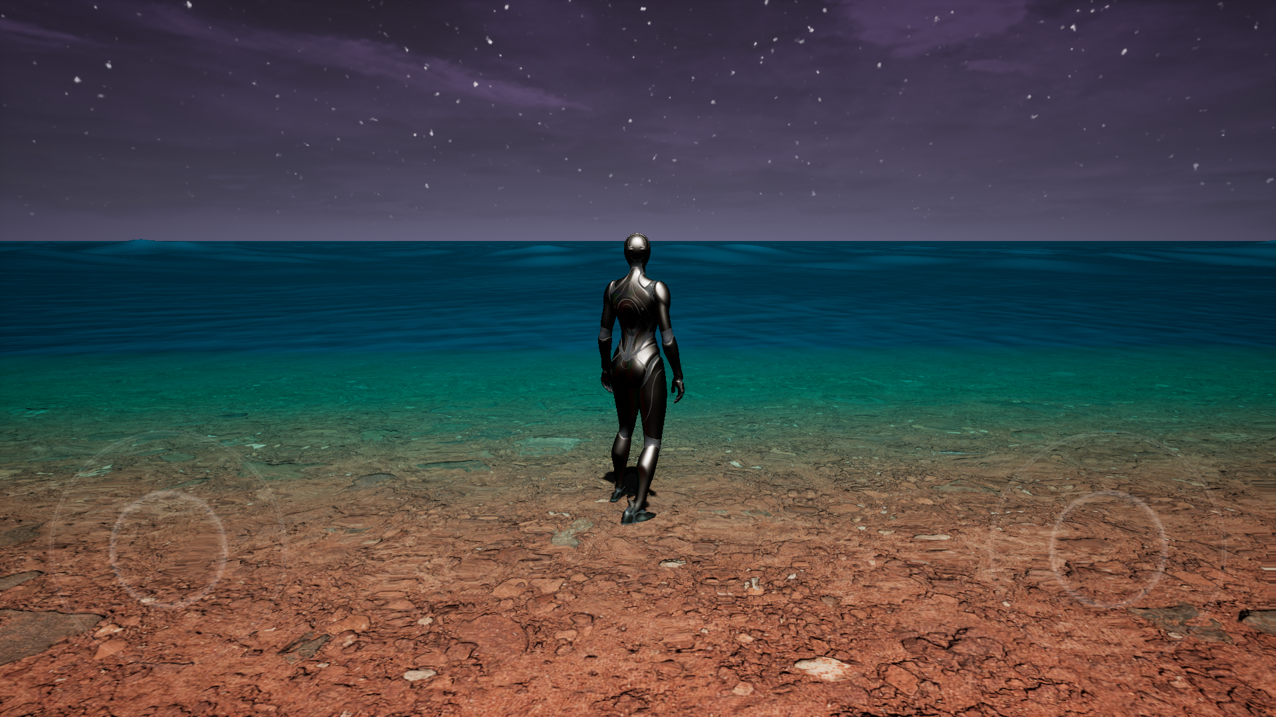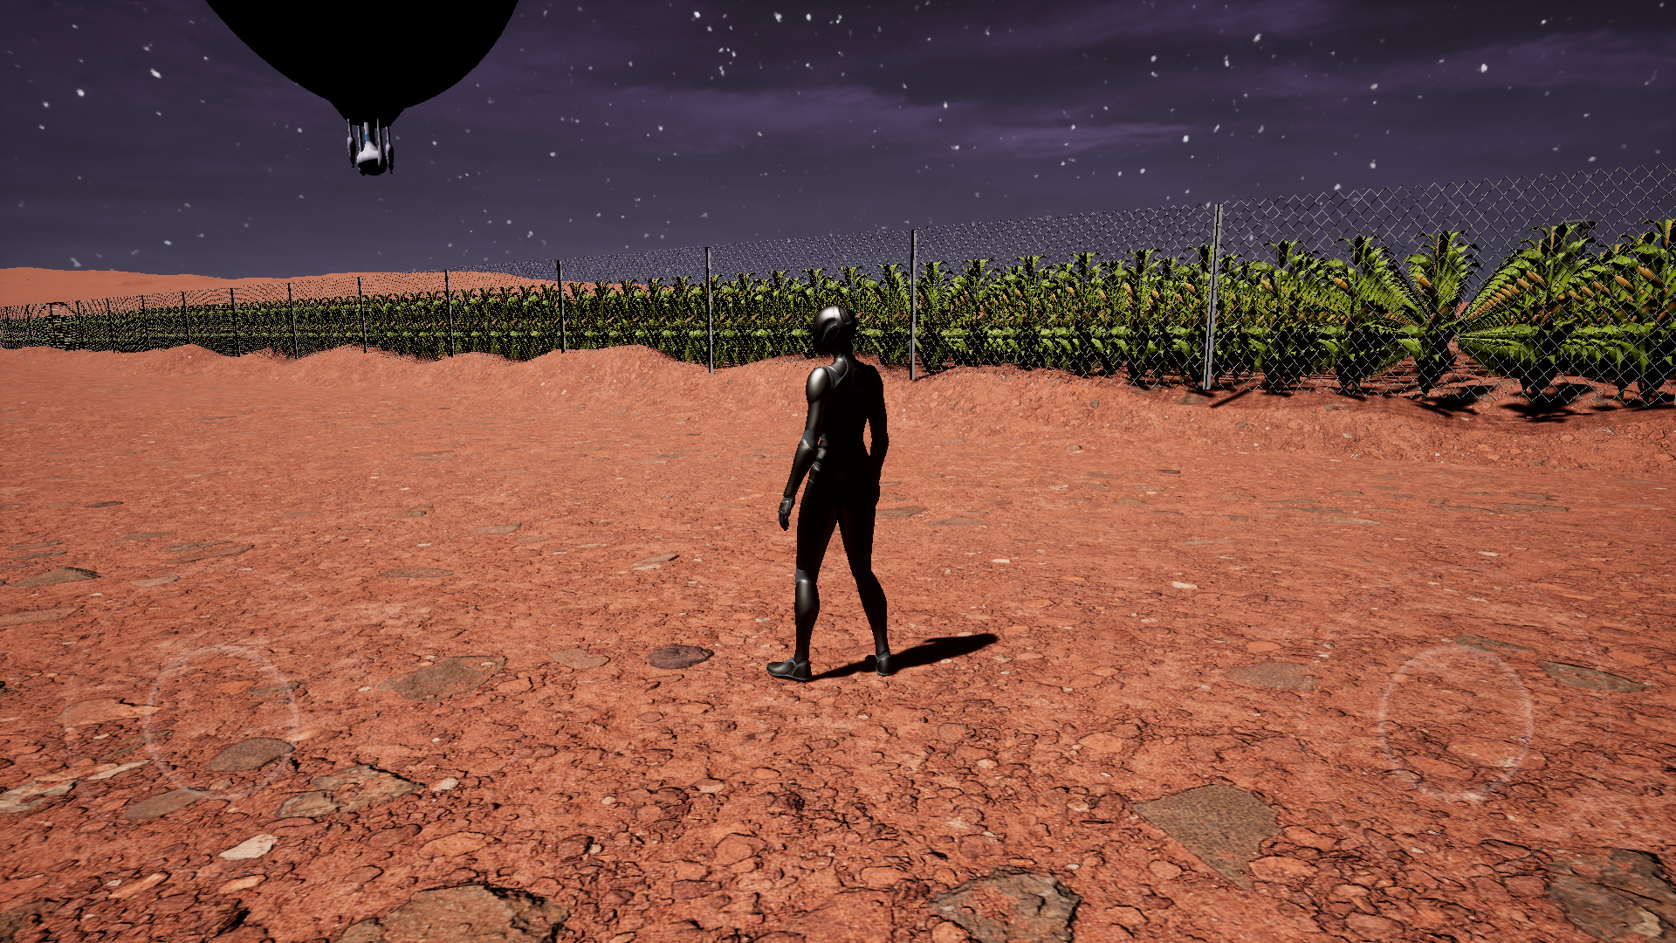

There are Teleporters we used so that Users can easily move on the planet.

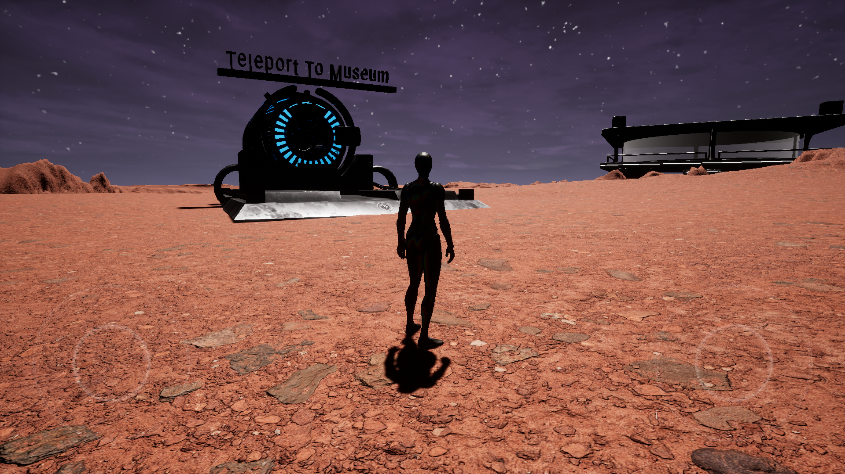

Rover is placed in the museum, which is used to collect data about a planet and helps researchers to complete research accurately.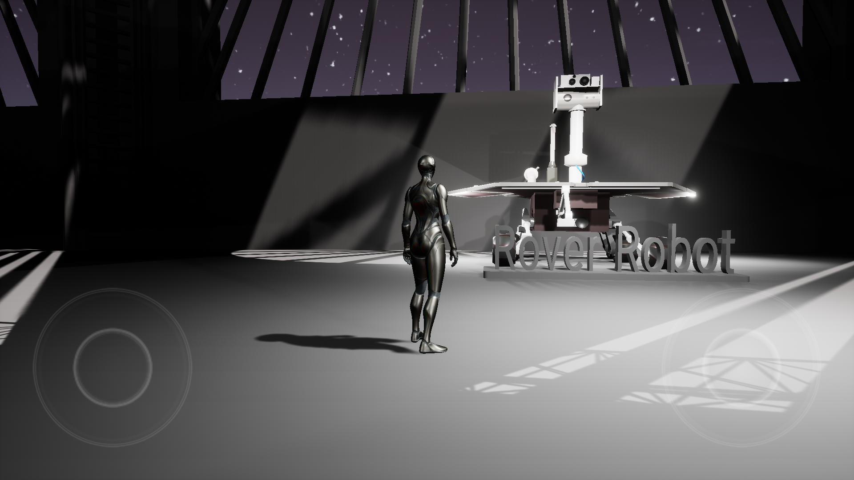

Application’s feature:

* A game-based environment
* Third Person Perspective
* Fictional project

Amenities:

* Users can easily experience a habitable planet except the Earth
* Students can play the game for fantasy besides they can learn about Exoplanets
* Educational institutes can use this model for learning purposes.

Expectations for Achievement:

* Users can use the data for research purposes
* All the misconceptions and misleading information about space and exoplanets can be solved
* Users can broaden their knowledge about space and exoplanets in a very interactive way

Tools:

Slide Edit: Canva and PowerPoint

Model development And Website:

* Unreal Engine 5
* C + +
* Eagle 3d streaming
* Visual Studio
* HTML, CSS

Space Data:

* For ISS: <https://nasa3d.arc.nasa.gov/detail/iss-hi-res>
* For space shuttle: <https://nasa3d.arc.nasa.gov/detail/shuttle-hi-res>
* For weather forecast: <https://mars.nasa.gov/insight/weather/>
* For Rover Cam: <https://mars.nasa.gov/mars2020/multimedia/images/>
* 55 Cancri e 3D Model: <https://exoplanets.nasa.gov/resources/2210/55-cancri-e-3d-model/>
* Proxima b 3D Model:<https://exoplanets.nasa.gov/resources/2211/proxima-b-3d-model/>
* For Voyager 2: <https://science.nasa.gov/resource/voyager-3d-model/>
* For Lunar Module: <https://nasa3d.arc.nasa.gov/detail/lunarlandernofoil-c>
* James Webb Telescope: <https://nasa3d.arc.nasa.gov/detail/jwst>
* Opportunity Rover: <https://mars.nasa.gov/resources/24883/spirit-and-opportunity-rover-3d-model/>
* Curiosity Rover: <https://mars.nasa.gov/resources/24584/curiosity-rover-3d-model/>
* Mars Perseverance Rover: https://mars.nasa.gov/resources/25042/mars-perseverance-rover-3d-model/